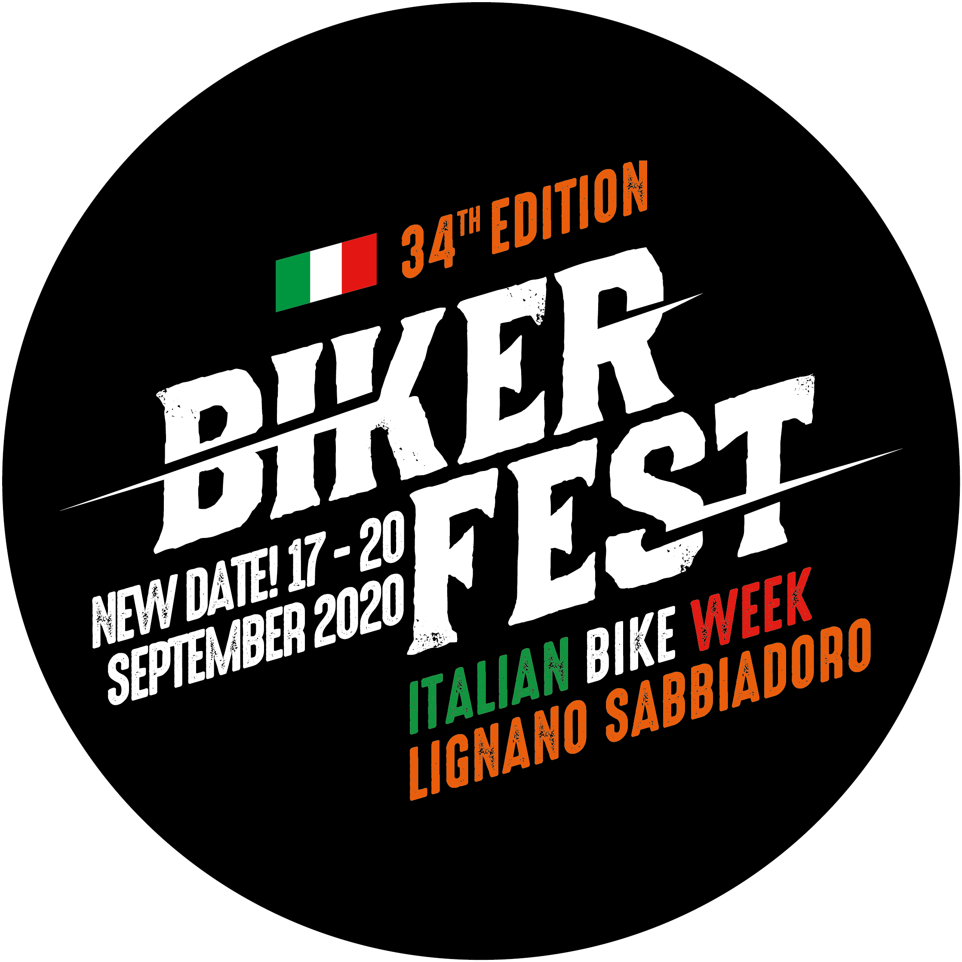
34th BIKER FEST INTERNATIONAL – THE ITALIAN BIKE WEEK
LIGNANO SABBIADORO (Udine) ITALY - 17th - 20th SEPTEMBER 2020

Lignano Sabbiadoro Italian Bike Week passed every rosy expectation in this hard moment, earning the title of the largest outdoor motorcycling event in Europe in 2020. It’s the Diamond tip of the Custom sector and a fundamental goal for full spectrum of motorcycle and engine lovers.

From 17th to 20th of September went to stage the 34th Biker Fest International in Lignano Sabbiadoro (Italy) with many news and traditional activities that were alternated during the four days of the event, livening up public tastes and passions.
A very brave edition respectful of the maximum security rules that organization made respect by a rigid protocol.
Authorities estimated near 90.000 participants, a very important number, especially in a year in which boots were at their first event and needed to get some fresh air, as soon as the guests who needed to “back home” to the event that more than every other in Europe represent them and offers space to all two and four wheels engine fans.
A wonderful weather went with all four event days allowing families to spend some serene day at the sea and to discover the incredible locations of this year: the headquarter Luna Park Strabilia, the very large Off Road Area and Stadium area (redoubled compared to the last year) with the presence of the main Motorcycle Firms that gave the possibility to try their models for Demo Rides and the new e-Mobility Village where people could try electric and hybrid four and to wheels vehicles. There were thousands of demo rides that surpassed last edition record of 2500 free tests.

New location in the centre of the Luna Park Strabilia for the most historic Custom Bike in Europe: the Italian Motorcycle Championship with about 100 custom bike registered coming from all over Italy and neighbouring nations. Winner bikes have been awarded on the main stage and those that won a place at the AMD World Championship in Colonia are: Moto Guzzi 850-T5 by Bepy Moto Service (Turin), Buell “Visione” by De Benedetti&Fiordi (Livorno-Brescia), BMW R65E (electric) by Free Sound Customs (Pisa) and the H-D “Ghisarama” by Hazard (Bergamo).
For the occasion the historic Austrian customizer Penz Performance presented in advance in Europe his new bagger, a wonderful example of value and rare refinement.

Seven kilometres of track were dedicated to all off road lovers with Enduno, mini Enduro and Scrambler Challenge; Garden Tractors Racing & Moped were the new entry.

In the renewed off road area with an oval track especially set up, pilots could drove across rising clouds of dust in the nearly unlimited curves, but it was also possible to take part to classes and rent 250 and 450 cc motorbikes thanks to Flat Track School.

Jeepers and other 4x4 enthusiast lovers could drove their vehicles on a long of road track to try their skills also on extreme plans well visible by public; more than 60 teams have been registered and showed off during all week-end

In the Luna Park area, as in the previous editions, there were more than 150 exhibitors to satisfy all public’s tastes, included food and beverage boots that offered specialties from different Nations.
A dozen of great motorcycle travellers took part at the event Moto Senza Frontiere (Motorbike without borders) curated as always by Maurizio De Biasio; on the main stage they could tell their great trip experiences, memories and advices, present their book and show wonderful images of thesi life on the road.

Saturday evening thanks to the cooperation of Morena Moto Club, took place the spectacular Lightning Parade along Lignano streets; on Friday and Saturday it organized also some guided tours to the historic cities of Aquileia, Cividale and Palmanova very appreciated from participants. It was a unique occasion to discover Friuli Venezia Giulia territory, a region very appreciated by bikers.

Every day some bands livened up the evenings with live music: from rock, rockabilly and Jazz to musical entertainment and acoustic. Obviously dance was forbidden: also official event T-Shirt said on the back side: “Social Distancing Expert 1m”! The memory of this strange edition will last in the years.

In addition to Jeep area, also four wheels had an important position in this Biker Fest edition with the 25th U.S. Car Reunion, the most historic event in this sector in Italy, with the participation of about 400 American Cars (almost all powerful V8 plus more than 60 Jeep team in the Off Road Area 4x4) that took part to an extraordinary parade along Lignano Streets on Sunday morning.

As every year the presence of the Official Motorcycle Brands in the Stadio Teghil area attracted many visitors for Demo Rides: free tests with news models made available by Honda, Kawasaki, Royal Enfield, Somoto, BMW Motorrad, Triumph, Maxxon Racing directly from Spain, Royal Alloy, NIU, Indian Motorcycle and Boss Hoss Cycles.

The most important news of this year was the E-mobility Village situated in the Stadio Teghil area where visitors could test for free different electric and hybrid vehicles, maybe the most important event dedicated to Green & Hybrid engines in Europe, with a big possibility to increase. This event has been organized in cooperation with Consorzio Lignano Holiday and gave large space to electrical mobility sector with prestigious brands as: Peugeot, DS, Mercedes Benz, BMW, Smart, Mini, Audi, Hyundai, Jeep, FIAT, Renault, Opel, Nissan, XEV, BMW Motorrad, NIU and E-Racer.
A challenge won by a staff guided by heart and passion, but also by rationality and expertise acquired during the years. One more time, after 34 years, the event received the feeling of a fantastic public, hosted in a city like Lignano Sabbiadoro that always supports this event and dresses up to give a great week end to its guests!

Biker Fest staff is still working for the 35th Biker Fest International that will take place form 13th to 16th May, 2021 and it will be a great birthday: the best Italian Bike Week like ever... the next!

For details and info about 34th Biker Fest International:
Web: www.bikerfest.it
Facebook: Biker Fest International / Event Biker Fest International
Instagram: Biker Fest Int LinkedIn: Evento Biker Fest
Twitter: Biker Fest International

HIGH RESOLUTION IMAGES
www.bikerfest.it/images/hq-pics/34a/completo/archivio_34a_completo.zip

You can download Press Release click on “Download Allegato” at the end of the page

ITALIAN MOTORCYCLE CHAMPIONSHIP
& AMD WORLD CHAMPIONSHIP CHART
34th BIKER FEST INTERNATIONAL

BEST IN SHOW I.M.C.
H-D “Ghisarama” by Hazard (BG) wins an AMD 1000 € voucher + prizes MBE
AMD WINNERS
Moto Guzzi 850-T5 by Bepy Moto Service (TO) wins an AMD 1000 € voucher
Buell “Visione” by De Benedetti&Fiordi (LI-BS) wins an AMD 1000 € voucher
BMW R65E (electric) by Free Sound Customs (LU) wins an AMD 1000 € voucher
CAFE RACER
1°- BMW K100 by Bottega Bastarda di Forlì (FC) wins a booth at Rome Motodays 2021
2°- HRD Vincent by PDF Motociclette (BG) wins Ma-Fra basket
3° - Triumph Trident, by Officine Civettini (BA) wins Ma-Fra prizes

SCRAMBLER
1°- Yahama XV 1000 by Remastered Cycles (BS) wins a 300 euro GIFT CARD by Alex De Pase Tattoo Studio + Prizes MBE
2°- H-D Scrambler by MdiM Garage Style (TV) wins Bertoni glasses
3°- Aprilia Pegaso by Mastercycles (TV) wins Ma-Fra prizes

OLD STYLE
1°- H-D Ironhead by Devils Garage (RC) wins a 300 euro Custom Chrome Europe voucher
2° - H-D Pan Chopper by PDF Motociclette (BG) wins a Motorcycle Storehouse Saddle + Edo Design prize
3° - Royal Enfield Bullet 500 by G. Design Custom Motorcycles (LO) wins Ma-Fra prizes

STREETFIGHTER
1° - Buell XB12 by Garajek (BG) wins 200 euro GIFT CARD by Alex De Pase Tattoo Studio
2° - Aprilia Tuono V4 by P.M Motorbike (SO) wins Bertoni glasses
3° - Honda CBR 600RR by Metal Dreams (VE) wins Ma-Fra prizes

MODIFIED H-D
1°- H-D XLM by Emporium Garage (BG) wins a 200 euro Custom Chrome Europe voucher
2° - H-D “Calavera” by MC Cycles (TV) wins a Motorcycle Storehouse saddle
3° - H-D Softail by Mastercycles (TV) wins MA-FRA prizes

METRIC
1° - Ducati M900 by Bottega Bastarda (FC) wins a Zodiac tank
2° - BMW K100 by Red's Garage (VI) wins Highway Hawk accessories
3° - Yamaha Drag Star by Edoardo Cinquetti (CR) wins MA-FRA prizes

BAGGER
1° - H-D Street Glide by Biker Sheriff (TV) wins a 200 euro Rebuffini voucher
2° - H-D Bagger by Asso Special Bike di Erba (CO) wins IMCO Motorcycle accessories
3° - H-D Bagger by Devils Garage (RC) wins MA-FRA prizes

FREESTYLE
1° - “Razzle Dazzle” by Penz Custombikes (Austria) wins a 500 euro Custom Chrome Europe voucher + Prizes MBE
2° - RevTech 100 by RCK Roll-Cop (NA) wins 200 euro GIFT CARDS by Alex de Pase Tattoo Studio
3° - H-D Shovel 1600 by Bulldog Garage (VE) wins prizes Ma-Fra

BEST BUDDING CUSTOMIZER
RAW Custom (PD) wins a boot at MBE in Verona 2021

BEST CENTRE-SOUTH ITALY CUSTOMIZER
Devils Garage from Reggio Calabria wins a booth at Rome MotoDays 2021

